Name ___________________________________ AP Calculus
Sections 5.1 – 5.3: Definite Integrals

Show all your work! Only use a calculator on problems marked with *.
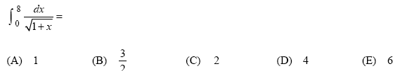
1.

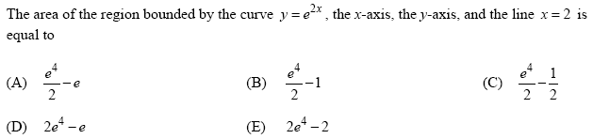
2.

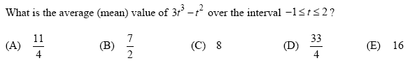
3.

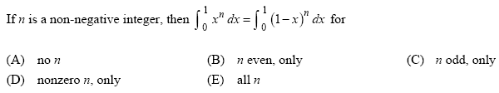
4.

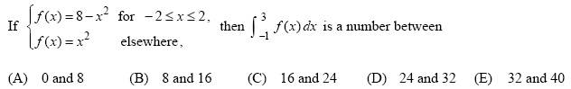
5.

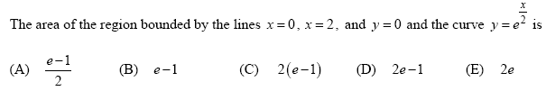
6.

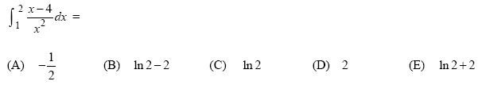
7.

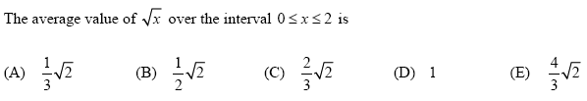
8.

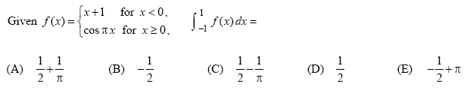
9.

10.
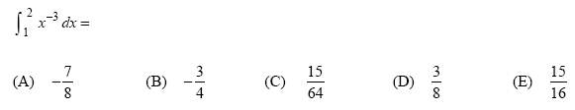

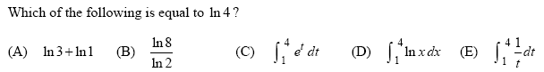
11.

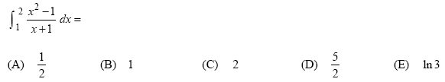
12.

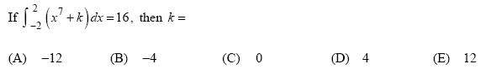
13.

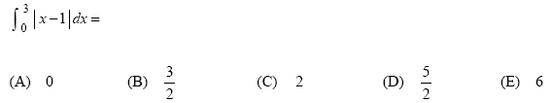
14.

15.
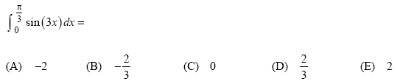

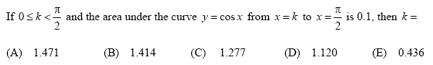
*16.

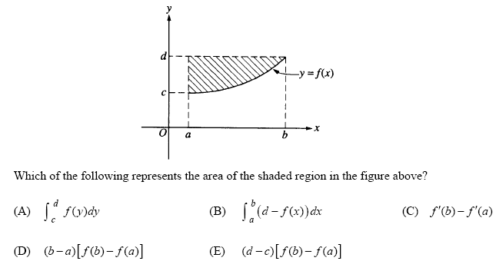
17.

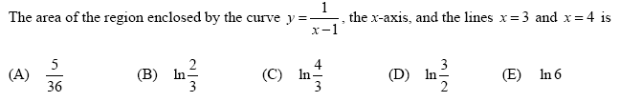
18.

